|  |  |  |  |
| --- | --- | --- | --- |
|  | | | |
|  |  |  | |
| **TITLE** | **:** | **Construct Network topology and Set Up LAN TCP/IP settings and connect two PC’s for file sharing via network cable.**  **[CLO-2, PLO-5]** | |
|  |  |  | |
| **DATE OF EXPERIMENT** | **:** | **21/02/23** | |
|  |  |  | |
| **Lab Number** | **:** | **02** | |
|  |  |  | |
|  |  |  | |
| **NAME** | **:** |  | **EISHA BAIG**  **___________________** |
| **ROLL NO** | **:** | **_____________200901015______** | |

**Objective:**

* Establish a connection between two laptops/PCs.
* File Sharing between two laptops/PCs.

**Equipment:**

* 2 Laptops / PC’s.
* Lan Cable.

**Procedure:**

1. Go to “Control Panel => Network and Internet => Network and Sharing Center => Change Adapter Settings.”
2. Click on “Change Adapter Settings.” This will reveal different connections. Select the appropriate connection for your LAN. Usually, but not necessarily, the connection will be called Ethernet and have the description network cable unplugged.

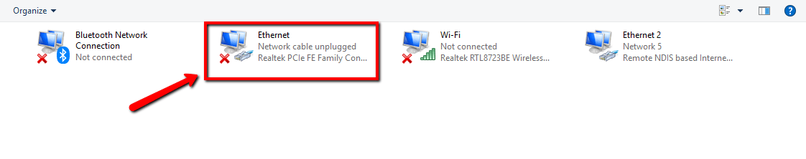

Right-click on the connection and select “Properties.” The local area’s connection properties window will appear.

1. Under the network tab select “Internet protocol version 4 (TCP/IPv4),” then click on “Properties.”

In the Properties windows set the IP address and subnet masks of the first computer to:

* + IP – 192.168.3.1
  + Subnet Mask – 225.225.225.0

For a second PC, use

* + IP – 192.168.3.2
  + Subnet Mask – 225.225.225.0

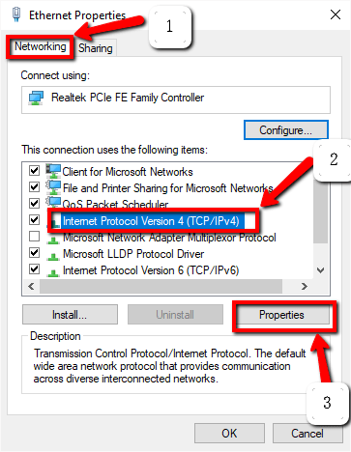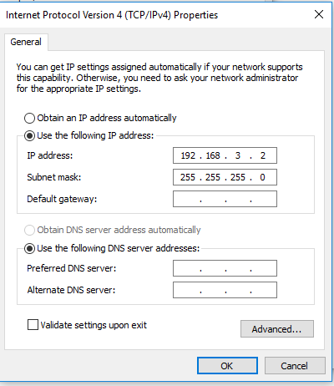

1. The next step is to connect the crossover cable to the network ports of the two computers. Both ends of the network cable look the same, so it does not matter which end you use first.
2. By doing the same steps on to the other computer and connecting them through connection wire both computers will appear on the network tab after turning on the network discovery “ON” on both PC’s.

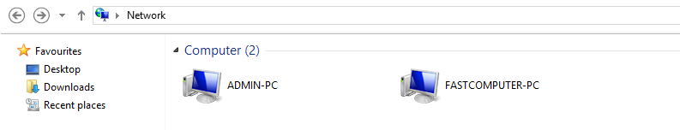

1. Now right click on to the file that have to be shared and click on sharing

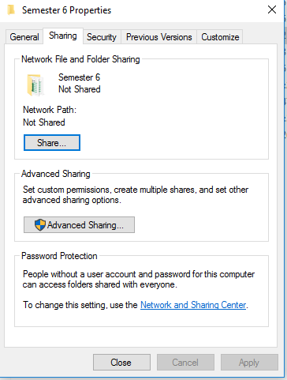

1. Click on to the “advanced sharing” and select the people you want and set permissions as everyone, read/write are selected in the following figure

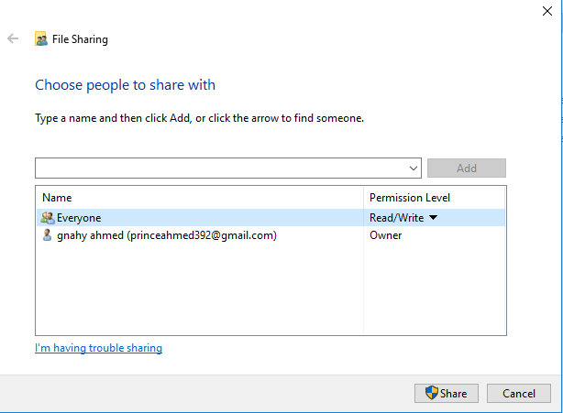

1. Shared files will appear like this

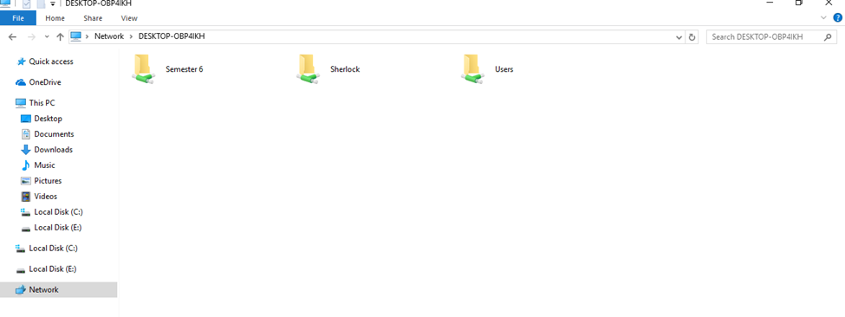

1. After complete sharing of data with other network turn off network discovery options and change IP address on both PC’s to Automatically Detection mode.

**Tasks:**

Connect two PC’s using the following configurations and setting via LAN cable.

Share files between two PC’s.

Construct topology for data sharing between two PC’s and Simulate on Packet tracer.

Working:

Select - > endsystem from packet tracer

Then select pc-0 and pc-1 from the send systems

After that connect them through the crossover cable or any other required available cable for the packet transfer.

After this we are going to set the ip address of pc-0 to 10.10.10.1 and pc-1 to 10.10.10.2

After that using the simulation we are going to send the packet from pc-0 to pc-1.

RESULT:

